PARENTAL MONITORING SYSTEM – DOCUMENTATION

Depending on the screenshot provided and functionalities discussed we will use the following classes and methods to make the application.

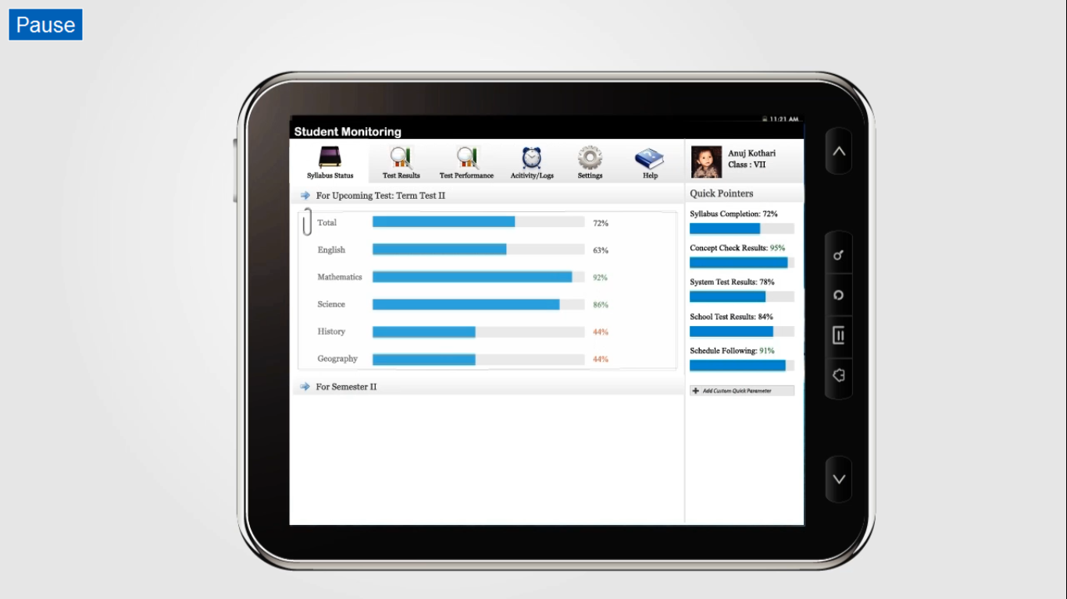

The screen will be divide into 2 fragments left and right i.e. LeftFragment.java & RightFragment.java .

**The right fragment** is a ListFragment - It basically provides quick references about the student, which our app covers.they used for most frequently viewed details. thus the quick pointers can be customized.

It will contain tab widget comprising of the

@drawable/student_image

@string/student_name

@/string/student_std

We will then have a list of objects below comprising of the pointers .The object contains

string_name

percentage

barchart – using achartengine api 0.7

button of add custom quick pointer

**The RightFragment will remain constant throughout the application.**

**CLASS USED FOR LIST ITEMS –**ArrayAdapter

**PARAMETERS PASSED** – Objects comprising of bar chart and string.

**The left fragment** consists of an main activity named MainActivity.java. Within the main activity tabhost will be created and corresponding tabs will be made. each tab will consist of an activity with different class for each of them. The details are given below.

1. **SyllabusStatusActivity.java**
2. **TestResultsActivity.java**
3. **TestPerformanceActivity.java**
4. **LogsActivity.java**
5. **SettingsActivity.java**
6. **HelpActivity.java**

Tab widget will contain @drawable/imagename.png and the @string/string_name.

**SyllabusStatusActivity.java**

The tab activity will be divided into layouts.

An ExpandableListView layout will be used to show the syllabus covered in upcoming tests and upcoming major test

**Classes used are**

Class SyllabusStatusActivity will extend ExpandableList Activity.

ExpandableListAdapter will be used to manage data as-

groups

containing statistical data (bar graph and % in each subject)

and children – will be disabled.

THE LAYOUTS WILL BE ADDED DYNAMICALLY IN ORDER TO EASE ADDITION OF SYLLABUS DATA FOR MORE THAN TWO TESTS.

Class MyExpandableListAdapter will be made to define the groups and children

class MyExpandableListAdapter will extend BaseExpandableListAdapter.

**Parameters passed are**

List of Group and Children will be passed as parameters.

three xml files will be created:

1. syllabusstatus_list.xml – to define the expandablelistview layout.
2. group_list.xml – for each group
3. child_list.xml – for each child in the group

**TestResultsActivity.java**

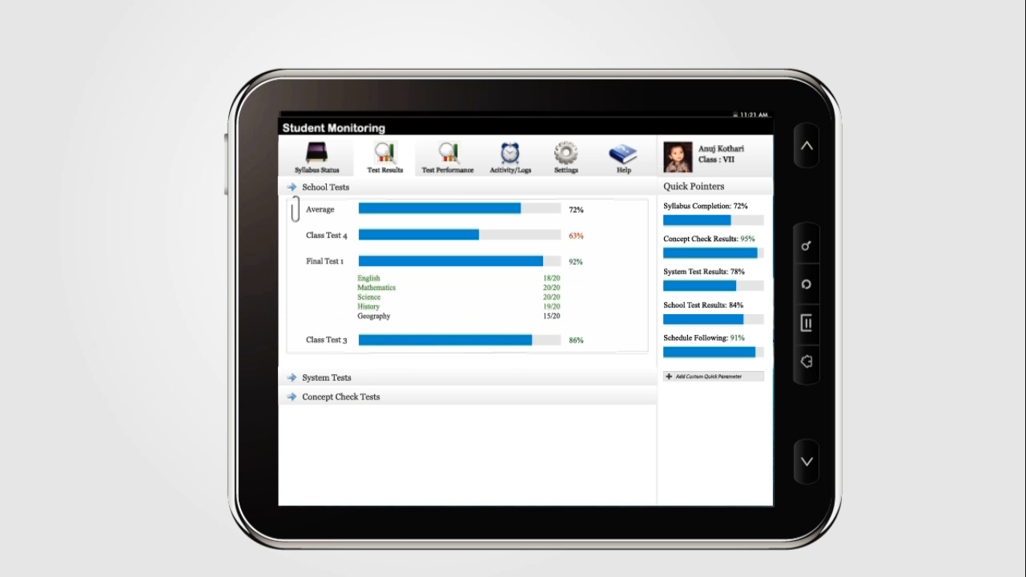

Similar to SyllabusStatusActivity we will have 3 layouts - One for School Tests, one for system tests and one for concept check tests.

and in each we will have an expandablelistview .

Each group in the expandablelist will have bar graph and % along with test names.The children of each will comprise of breakage of marks according to subject.(green/red for pass/fail).

**TestPerformanceActivity.java**

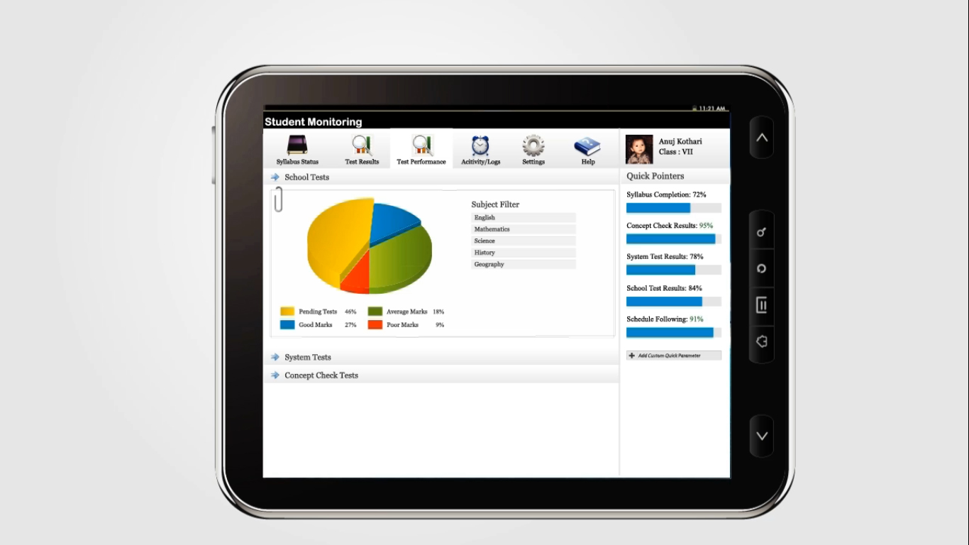

Similar to the SyllabusStatusActivity we will make use of ExpandableListView within 3 layouts again.

We will be using different api for making 3d pie chart or 2d chart using canvas .

**LogsActivity.java**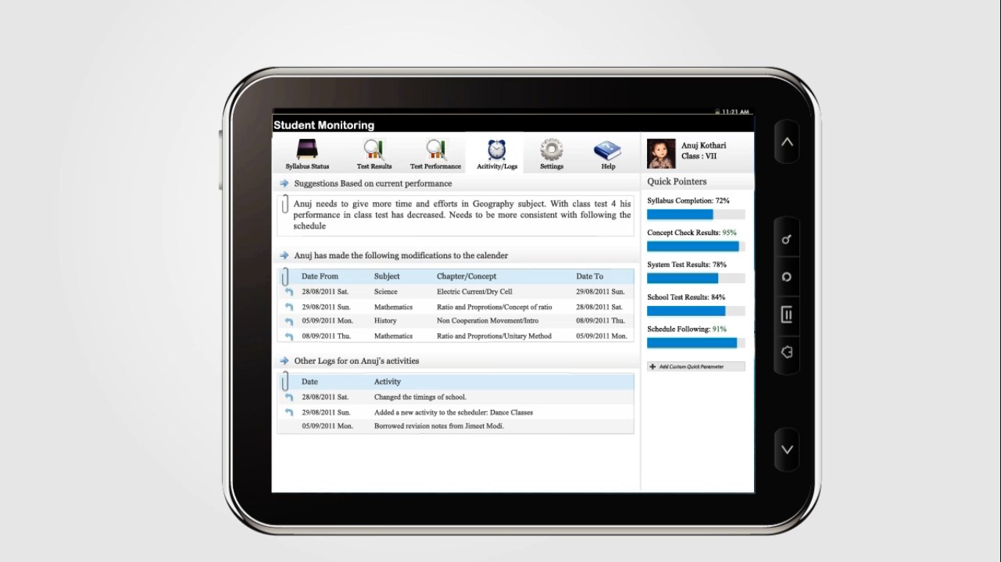

Here we make use of the ExpandableListView within 3 layouts.

group – Suggestion Based on Current Performance.Here the children display logs and hence won’t be clickable.